Celebrations On the Other Side of the World: Childhood Traditions in Central Asia and Mongolia
Lesson Plan
For Teachers
This lesson plan uses examples from the lives of children in Central Asia and Mongolia to show students how people celebrate important events in other communities. It is aimed at 1st-3rd-grade students who are beginning to learn about the world outside their family home and to make connections between their own and others’ experience. However, we have included material at the end that might be used with older age groups.
The lesson offers:
- An opportunity for students to think about what they know and share ideas in class discussion.
- A simple map coloring activity (countries could also be pointed out on a class map or globe—the latter in particular could be used to show that these countries are literally on the other side of the world to the USA)
- A reading activity that can be done as a class, with students listening and following the text, or as an independent reading.
- A chance for students to recall and retell what they heard/read.
- A reflexive activity in which students write about and draw their own favorite celebration.
Following the lesson printouts (6 pages), we have included some more detailed information about a wider selection of Central and Inner Asian traditions relating to childhood and growing up. This is intended as extra information for teachers, but might also be used as material for more advanced readers. For example, it could be cut into sections and shared around the class as a group reading/listening activity, and/or provide the starting point for a research project to find out about other ways that important childhood milestones are celebrated around the world.
Online Extension
See this tutorial for how use Google’s My Maps to create an interactive map with your students: https://www.youtube.com/watch?v=Tl0hDQqCCEU
Students can share what they find out with the class by tagging locations with information, links to websites, and pictures.
Celebrations On the Other Side of the World

First, think about these questions:
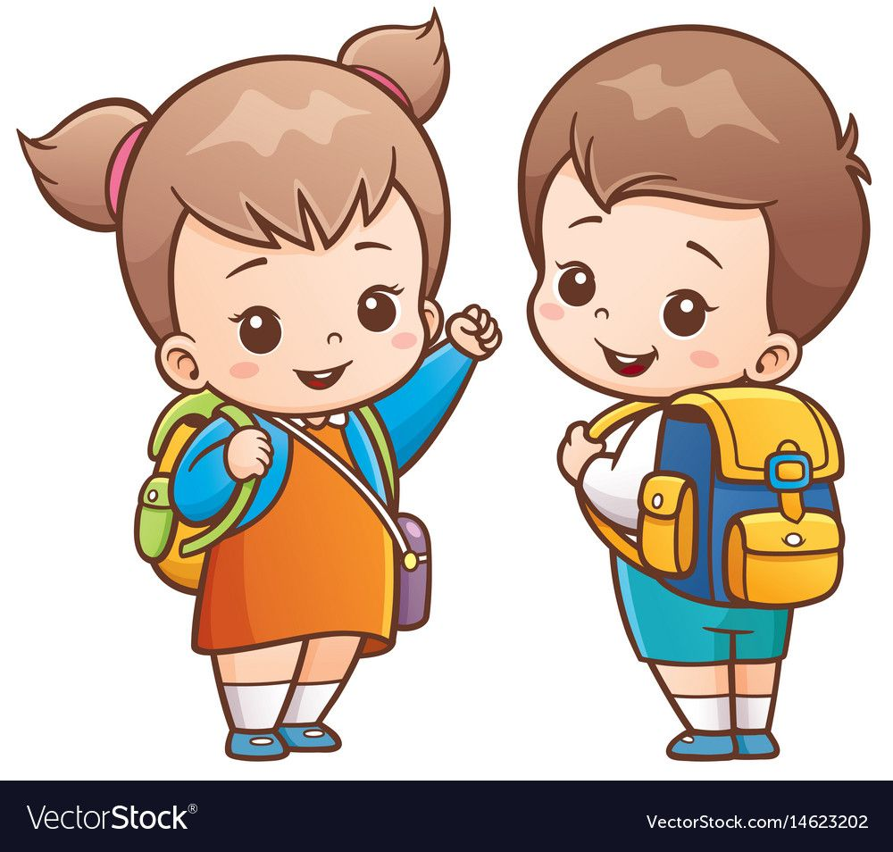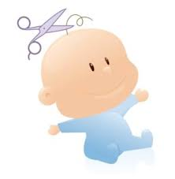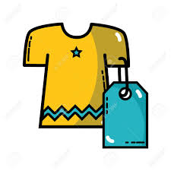
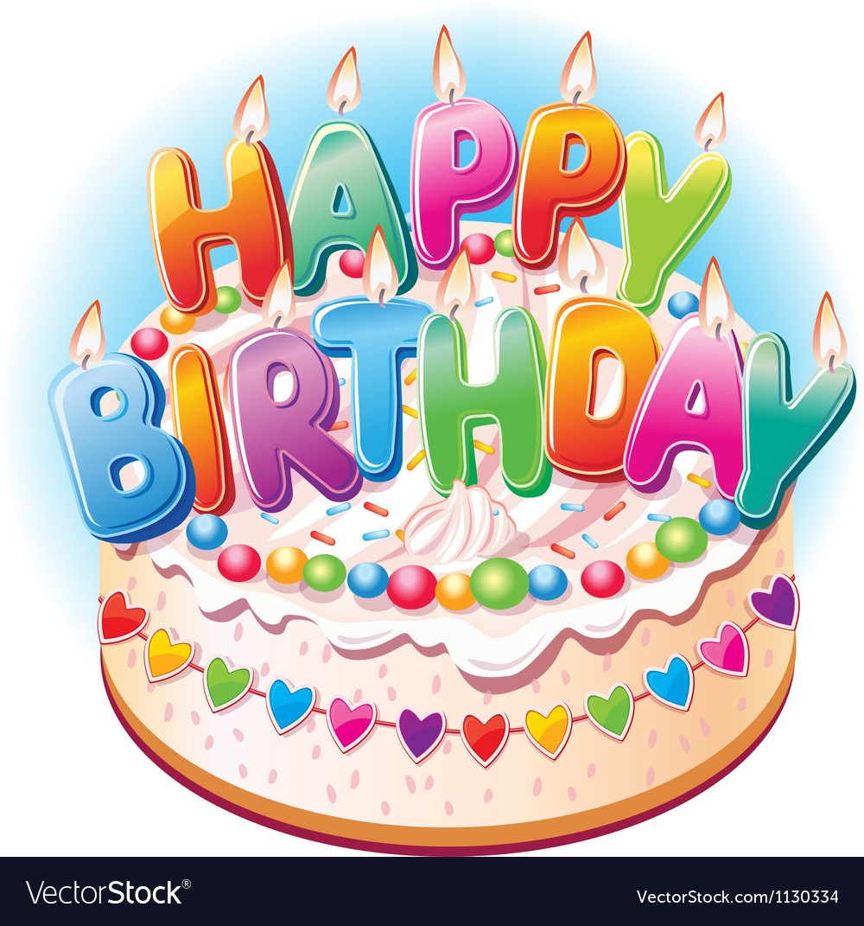
In your family, what do you do
- on someone’s birthday?
- when you get your first haircut?
- when you lose a tooth?
- when you get new clothes?
- on your first day at school?

In other countries, people celebrate these special moments in different ways.
You are going to learn about some of the ways people celebrate in three countries: Kyrgyzstan (kir-giz-stan), Kazakhstan (kaz-ak-stan), and Mongolia (Mong-goh-lee-ya).

Look at the map on the next page. Find the countries and color them in!

USA – blue
Kazakhstan – yellow
Kyrgyzstan – red
Mongolia - green

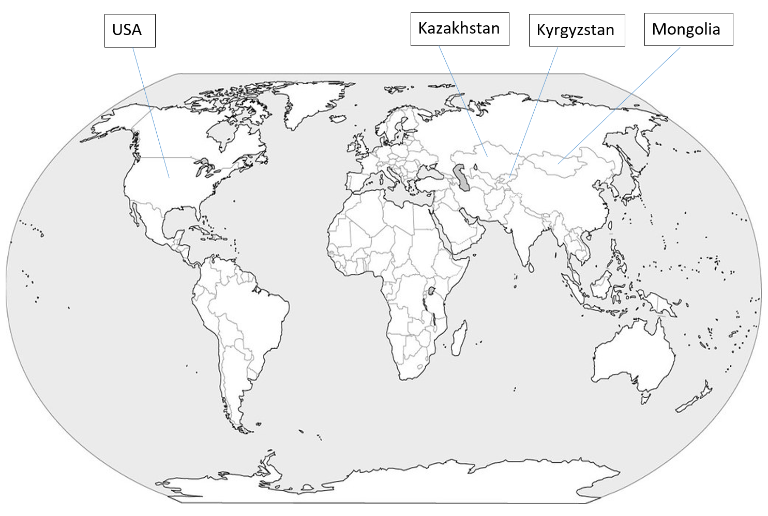
Read about these celebrations and draw a cross through the picture that doesn’t fit. The first one is done for you.

First Birthdays
In Kyrgyzstan and Kazakhstan, a 1st birthday is when people celebrate a child learning to walk. First, a string is tied between the child’s ankles. Then, someone special cuts the string and helps the child take their first steps. Sometimes, there is a running race and the winner cuts the string.
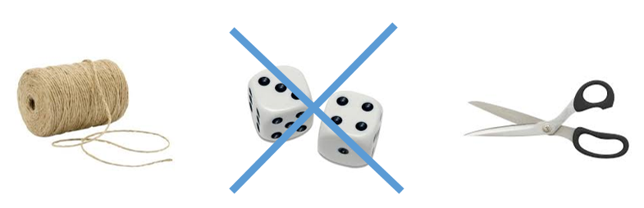
First Haircut
In Mongolia, children get their first haircut when they are three or four years old. Everyone gets together in the family home. Each person cuts off a little of the child’s hair. After that, there is a delicious meal with milk tea.

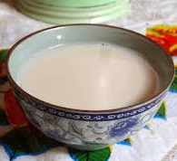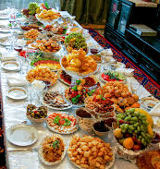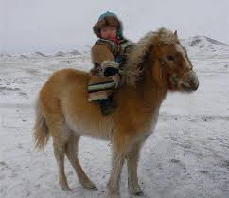

Losing a Tooth
In Mongolia, when a child loses a tooth they give it to a dog. They tell the dog: “Take my bad tooth and give me one of your good ones!”

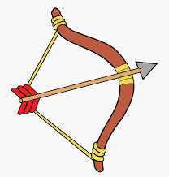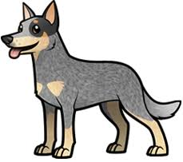

New Clothes
In Mongolia, children go to all the neighbors’ houses to show off their beautiful new clothes, and the neighbors give them candies and cookies.

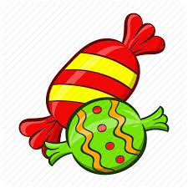

First Day at School
In Kazakhstan and Kyrgyzstan, children start school when they are seven years old. On the first day of school, parents take flowers to the teacher. Sometimes, they have a party at home for family and friends.

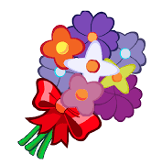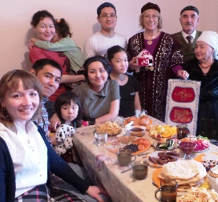

Look at the pictures. What do you remember about these celebrations?

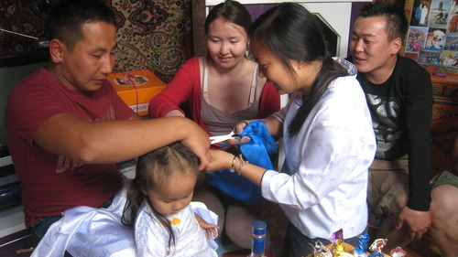

What the best celebration where you live? Why do you like it?

______________________________________________________________________________________________________________________________________________________________________________________________________________________________________________________________________________________________________________________________________________________________________________________________________________________________________________________________________________________________________________________________________________________________________________________________________________________________________________________________________________________________________________
Draw a picture of your favorite celebration here:

Childhood Traditions of Central and Inner Asia

40 days old
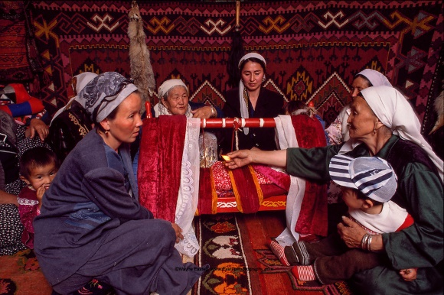
People in Kyrgyzstan, Kazakhstan and Uzbekistan all celebrate the moment at 40 days old when the baby is first placed in the cradle. Female relatives will gather to wash the baby, perhaps burn herbs to ward off evil spirits, and sing the baby to sleep in the new cradle. Friends and relatives may also bring gifts for the baby.
The Uyghurs in western China also have a special celebration when a baby is 40 days old. The parents invite children in the neighborhood to come to their home. The children take it in turns to pour a spoonful of water over the baby’s head and give the baby their best wishes for the life ahead. The children who take part receive candies and gifts from the parents of the baby.
First Birthday
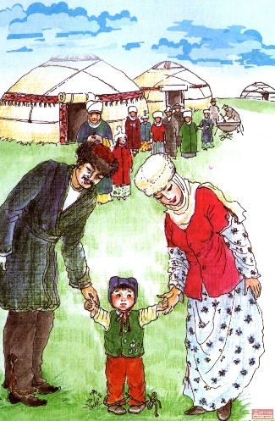
In Kyrgyzstan and Kazakhstan, on a child’s 1st birthday the family holds a special ceremony to celebrate the child beginning to learn to walk in which a string or ribbon is tied between the child’s ankles and a special person cuts the string and helps the child to take their first steps. It is a great honor to be the person who cuts the string. Sometimes a running race is held and it is the winner who cuts the ribbon and helps the child take their first steps in the hope that the child will inherit the agility and success of the race winner. Sometimes the parents will ask someone they respect to take on this role, also in the hope that the child will inherit the qualities of the person chosen. After the first steps have been taken, the child might be asked to choose between three objects – generally, money, a book and an instrument – and their choice will show what the child’s future holds.

Teeth and Hair
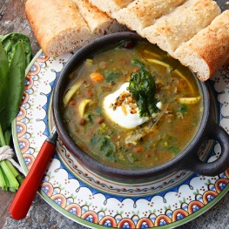
In Iran, the family celebrate the arrival of a child’s first tooth by cooking a hearty soup called “osh” and enjoying a delicious meal.
In Mongolia, when you lose a tooth you stick it into a lump of animal fat and feed it to a dog, and you ask the dog to make sure that your new tooth is a good one.
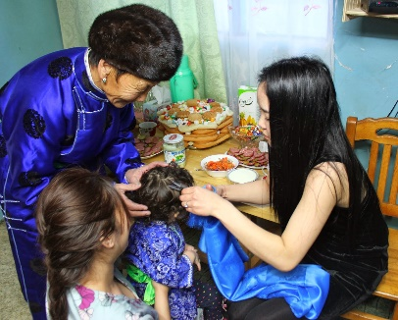
In Mongolia, a child’s first haircut is a festive occasion. This usually happens when a child is three or four years old. A lucky day is chosen based on the lunar calendar, and everyone gathers in the family’s “ger” (yurt) to take part. Someone with a lunar birth sign that goes well with the child’s own sign will cut the first lock of hair. Then the child goes from person to person, and each person cuts a little of the child’s hair. Once the hair-cutting ceremony is over, everyone enjoys a delicious meal with milk tea.
On this and other happy occasions in Mongolia, it is typical to eat rice cooked with butter, sugar and raisins. Because rice grows from a small handful into a great bowlful, it is seen as a symbol of abundance and so a good thing to celebrate with.
Clothes
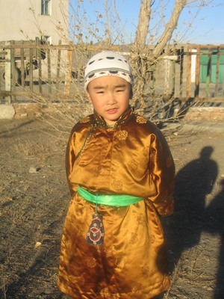
Also in Mongolia, traditionally, when a mother finishes making a new outfit for a child to wear, the child will go around to all the neighbors’ houses to show off their beautiful new clothes, and the neighbors will give the child candies and cookies.

School
On a child’s first day at school, it is common in Central Asia for parents to take flowers to the teacher and sometimes hold a celebration at home to which friends and neighbors are invited.
The first day of the school year in this part of the world is always September 1.
On September 14, people in Xinjiang (and all of China) celebrate Teachers’ Day. Children bring flowers and gifts for their teachers. In the afternoon, lessons are cancelled and the school holds a party in which students put on singing and dancing performances for their teachers. June 1 is International Children’s Day, when students parade through the town and take part in singing, dancing and sport competitions.
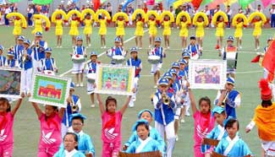
Birthdays
In Kyrgyzstan and Kazakhstan, the important birthdays come every 12 years: 12, 24, 36, 48… On these birthdays, someone close to you should buy you something red, and you should give something which is precious to you as a gift to someone else.
In Iran, they sing a version of “Happy Birthday” but in Persian and with a different tune.
Games
Children in Kyrgyzstan play a version of Telephone, except they call it “Broken Phone!”
In Kyrgyzstan, Kazakhstan and Mongolia, children play games with sheep knuckle bones. In one version, the bones are painted different colors and lined up in a row. Players also have bones to throw with. They take turns to take aim and try to break the line and win points.
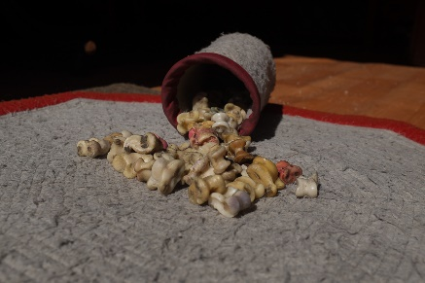
In Kazakhstan, children play a game called toghyz komalak – which literally means “Nine Sheep’s Droppings!” Traditionally, this game would have been played with dried sheep’s droppings. In a tactical game, each player has nine pieces and the first player to get rid of all of them is the winner.
In Iran, children play a game called “Jumping Wolf” – which is just like our game of “Leap Frog.”

And of course everyone loves soccer!

